NAMA : ANGGA DWI SAPUTRO
NIM : 253307019
KELAS : 2A
MATKUL : DESAIN DAN PEMROGRAMAN WEB

DOKUMENTASI SNAPSHOT INDEX MODUL 11

- Tampilan Index atau beranda
Code :
<?php
include("koneksi.php");

$countDosen = mysqli_fetch_assoc(mysqli_query($link, "SELECT COUNT(*) as total FROM t_dosen"))['total'];
$countMhs = mysqli_fetch_assoc(mysqli_query($link, "SELECT COUNT(*) as total FROM t_mahasiswa"))['total'];
$countMK = mysqli_fetch_assoc(mysqli_query($link, "SELECT COUNT(*) as total FROM t_matakuliah"))['total'];
?>
<!DOCTYPE html>
<html lang="id">
<head>
<meta charset="UTF-8">
<meta name="viewport" content="width=device-width, initial-scale=1.0">
<title>Sistem Informasi Akademik</title>
<link rel="stylesheet" href="style.css">
</head>
<body>
<div class="app-wrapper">

<div class="sidebar-overlay" id="sidebarOverlay"></div>

<aside class="sidebar" id="sidebar">
<div class="brand">
<div>SIA <span>Academic</span></div>
<button class="close-btn" id="closeSidebar">&times;</button>
</div>

<div class="sidebar-profile">
<div class="avatar">👤</div>
<div>
<div>Administrator</div>
<div style="font-size:0.75rem; color:#94a3b8; font-weight:400;">admin@sia.edu</div>
</div>
</div>

<ul class="sidebar-menu">
<div class="menu-header">Dashboard</div>
<li class="active"><a href="index.php">🏠 Dashboard Akademik</a></li>

<div class="menu-header">Master Data</div>
<li><a href="viewdosen.php">👨‍🏫 Data Dosen</a></li>
<li><a href="viewmahasiswa.php">🎓 Data Mahasiswa</a></li>
<li><a href="viewmatakuliah.php">📚 Data Mata Kuliah</a></li>
</ul>
</aside>

<div class="main-body">

<header class="top-header">
<button class="toggle-btn" id="openSidebar">☰</button>
<div class="header-title">Sistem Informasi Akademik</div>
</header>

<main class="content-area fade-in">
<div class="breadcrumb-container">
<div class="path">Home » Dashboard</div>
<h1>Dashboard</h1>
</div>

<div class="stats-grid">
<a href="viewdosen.php" class="stat-card dosen">
<div class="stat-info">
<div class="stat-value"><?php echo $countDosen; ?></div>
<div class="stat-label">Total Data Dosen</div>
</div>
<div class="stat-icon">👨‍🏫</div>
</a>

<a href="viewmahasiswa.php" class="stat-card mahasiswa">
<div class="stat-info">
<div class="stat-value"><?php echo $countMhs; ?></div>
<div class="stat-label">Total Data Mahasiswa</div>
</div>
<div class="stat-icon">🎓</div>
</a>

<a href="viewmatakuliah.php" class="stat-card matakuliah">
<div class="stat-info">
<div class="stat-value"><?php echo $countMK; ?></div>
<div class="stat-label">Total Mata Kuliah</div>
</div>
<div class="stat-icon">📚</div>
</a>
</div>
</main>

<footer class="footer">
&copy; <?php echo date('Y'); ?> Sistem Informasi Akademik — Sidebar Off-Canvas Model
</footer>
</div>
</div>

<script>
const sidebar = document.getElementById('sidebar');
const overlay = document.getElementById('sidebarOverlay');
const openBtn = document.getElementById('openSidebar');
const closeBtn = document.getElementById('closeSidebar');

// Fungsi untuk membuka / menutup sidebar
function toggleSidebar() {
sidebar.classList.toggle('active');
overlay.classList.toggle('active');
}

// Jalankan fungsi ketika tombol diklik
openBtn.addEventListener('click', toggleSidebar);
closeBtn.addEventListener('click', toggleSidebar);

// Tutup otomatis jika area gelap (overlay) di luar sidebar diklik
overlay.addEventListener('click', toggleSidebar);
</script>
</body>
</html>

- Hasil running file index.html
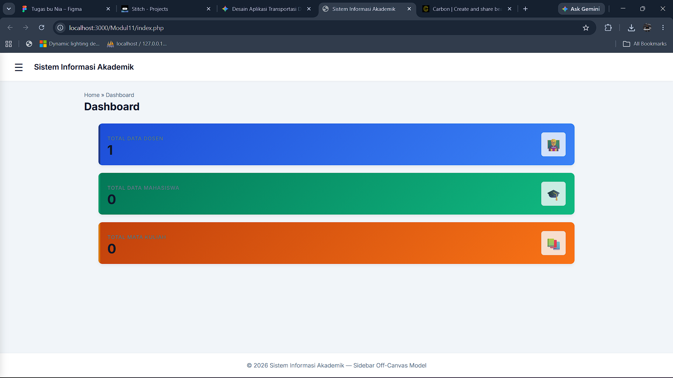

- Tampilan Dosen
Code :
<?php
include("koneksi.php");

// Fitur pencarian
$search = "";
$whereClause = "";
if (isset($_GET['search']) && !empty($_GET['search'])) {
$search = mysqli_real_escape_string($link, $_GET['search']);
$whereClause = " WHERE namaDosen LIKE '%$search%'";
}

$query = "SELECT * FROM t_dosen" . $whereClause . " ORDER BY idDosen ASC";
$result = mysqli_query($link, $query);
?>
<!DOCTYPE html>
<html lang="id">
<head>
<meta charset="UTF-8">
<meta name="viewport" content="width=device-width, initial-scale=1.0">
<title>Data Dosen — SIA</title>
<link rel="stylesheet" href="style.css">
</head>
<body>
<div class="app-wrapper">

<div class="sidebar-overlay" id="sidebarOverlay"></div>

<aside class="sidebar" id="sidebar">
<div class="brand">
<div>SIA <span>Academic</span></div>
<button class="close-btn" id="closeSidebar">&times;</button>
</div>

<div class="sidebar-profile">
<div class="avatar">👤</div>
<div>
<div>Administrator</div>
<div style="font-size:0.75rem; color:#94a3b8; font-weight:400;">admin@sia.edu</div>
</div>
</div>

<ul class="sidebar-menu">
<div class="menu-header">Dashboard</div>
<li class="<?php echo (basename($_SERVER['PHP_SELF']) == 'index.php') ? 'active' : ''; ?>"><a href="index.php">🏠 Dashboard Akademik</a></li>

<div class="menu-header">Master Data</div>
<li class="<?php echo (in_array(basename($_SERVER['PHP_SELF']), ['viewdosen.php', 'inputdosen.php', 'editdosen.php'])) ? 'active' : ''; ?>"><a href="viewdosen.php">👨‍🏫 Data Dosen</a></li>
<li class="<?php echo (in_array(basename($_SERVER['PHP_SELF']), ['viewmahasiswa.php', 'inputmahasiswa.php', 'editmahasiswa.php'])) ? 'active' : ''; ?>"><a href="viewmahasiswa.php">🎓 Data Mahasiswa</a></li>
<li class="<?php echo (in_array(basename($_SERVER['PHP_SELF']), ['viewmatakuliah.php', 'inputmatakuliah.php', 'editmatakuliah.php'])) ? 'active' : ''; ?>"><a href="viewmatakuliah.php">📚 Data Mata Kuliah</a></li>
</ul>
</aside>

<div class="main-body">

<header class="top-header">
<button class="toggle-btn" id="openSidebar">☰</button>
<div class="header-title">Sistem Informasi Akademik</div>
</header>

<main class="content-area fade-in">
<div class="breadcrumb-container">
<div class="path">Home » Master Data</div>
<h1>Data Dosen</h1>
</div>

<div class="card">
<div class="actions-bar">
<form class="search-bar" action="viewdosen.php" method="get">
<input type="text" name="search" placeholder="Cari nama dosen..." value="<?php echo htmlspecialchars($search); ?>">
<button type="submit">🔍 Cari</button>
</form>
<a href="inputdosen.php" class="btn btn-primary">➕ Tambah Dosen</a>
</div>

<table class="data-table">
<thead>
<tr>
<th>ID</th>
<th>Nama Dosen</th>
<th>No HP</th>
<th>Aksi</th>
</tr>
</thead>
<tbody>
<?php
if (mysqli_num_rows($result) > 0) {
while ($data = mysqli_fetch_assoc($result)) {
echo "<tr>";
echo "<td>$data[idDosen]</td>";
echo "<td>" . htmlspecialchars($data['namaDosen']) . "</td>";
echo "<td>" . htmlspecialchars($data['noHP']) . "</td>";
echo '<td class="action-links">
<a href="editdosen.php?idDosen='.$data['idDosen'].'" class="btn btn-warning btn-sm">✏️ Edit</a>
<a href="hapusdosen.php?idDosen='.$data['idDosen'].'" class="btn btn-danger btn-sm"
onclick="return confirm(\'Anda yakin akan menghapus data?\')">🗑️ Hapus</a>
</td>';
echo "</tr>";
}
} else {
echo '<tr><td colspan="4"><div class="empty-state"><div class="icon">📭</div><p>Belum ada data dosen' . ($search ? ' untuk pencarian "' . htmlspecialchars($search) . '"' : '') . '</p></div></td></tr>';
}
?>
</tbody>
</table>
</div>
</main>

<footer class="footer">
&copy; <?php echo date('Y'); ?> Sistem Informasi Akademik — Sidebar Off-Canvas Model
</footer>
</div>
</div>

<script>
const sidebar = document.getElementById('sidebar');
const overlay = document.getElementById('sidebarOverlay');
const openBtn = document.getElementById('openSidebar');
const closeBtn = document.getElementById('closeSidebar');

function toggleSidebar() {
sidebar.classList.toggle('active');
overlay.classList.toggle('active');
}

openBtn.addEventListener('click', toggleSidebar);
closeBtn.addEventListener('click', toggleSidebar);
overlay.addEventListener('click', toggleSidebar);
</script>
</body>
</html>

- Hasil running file edit dosen melalui index
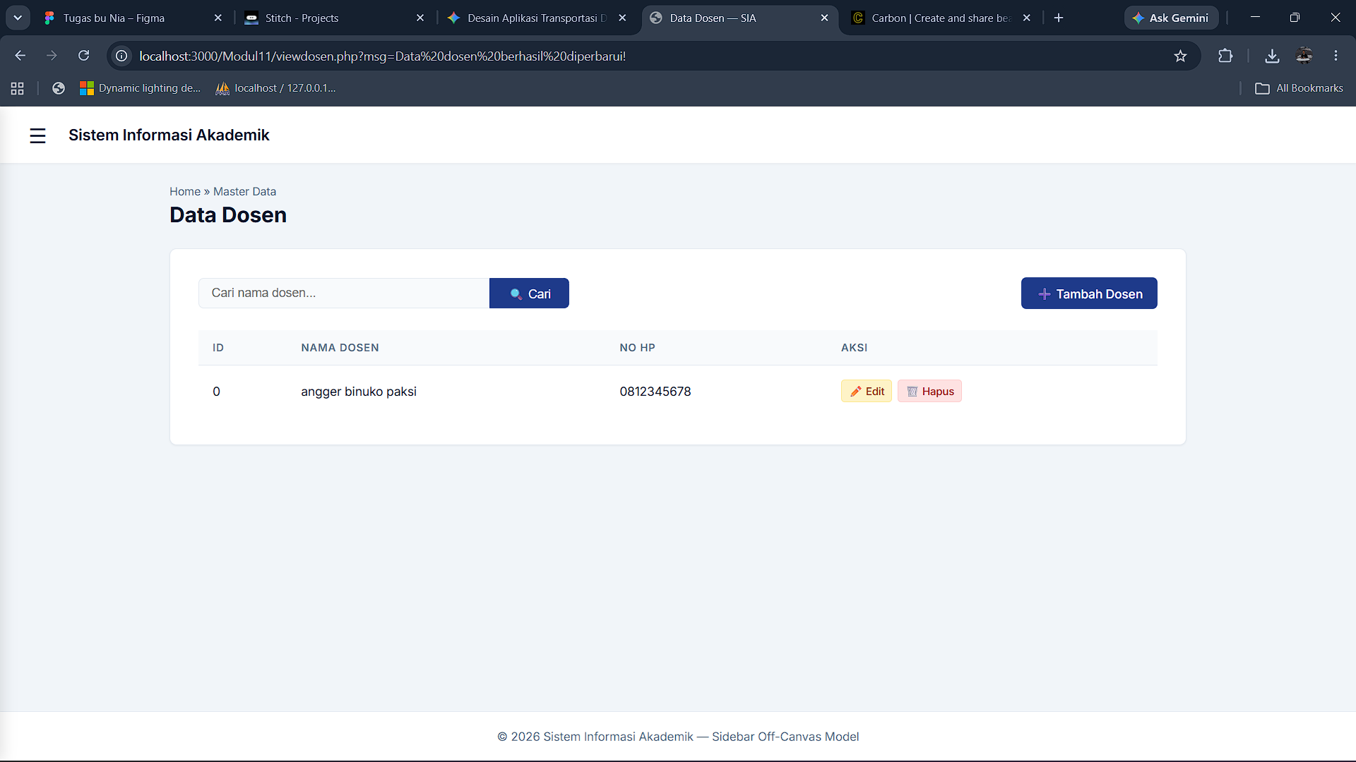

- Tampilan Tambahkan dosen
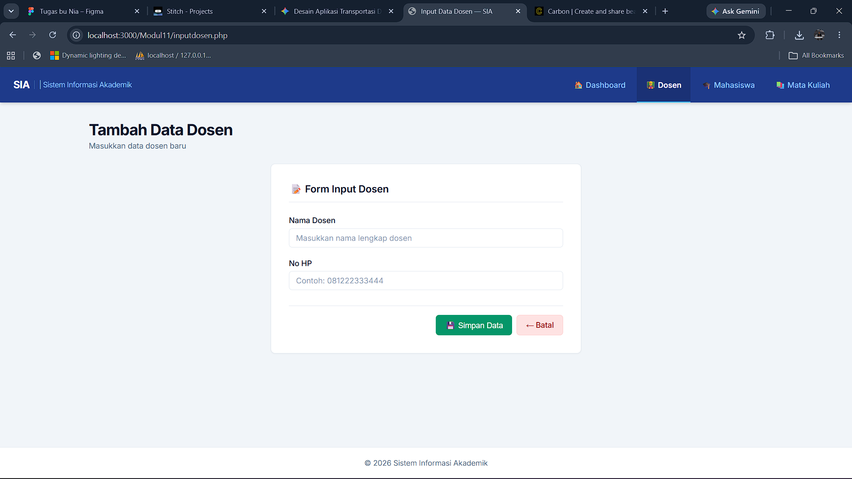

- Tampilan Edit Dosen
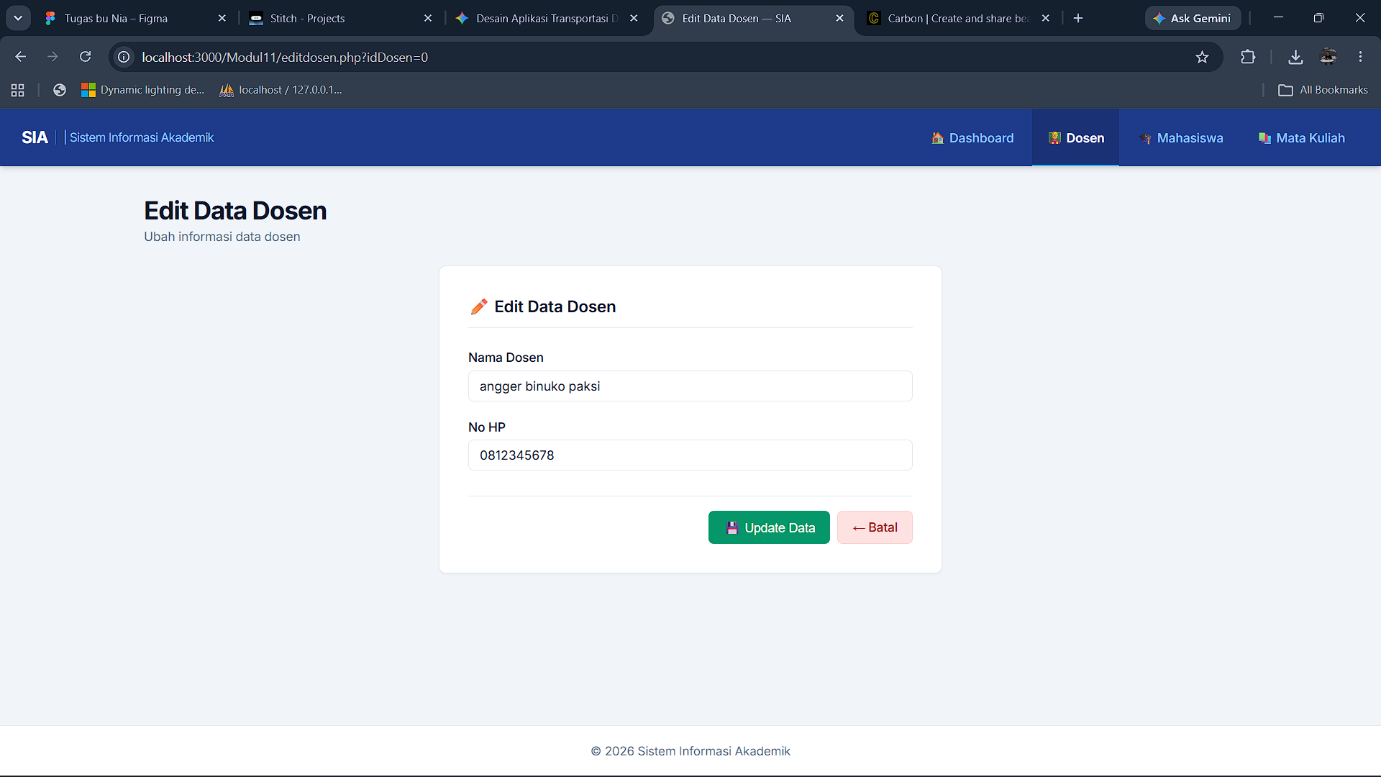

- Tampilan Mahasiswa
Code :
- <?php
- include("koneksi.php");

- // Fitur pencarian
- $search = "";
- $whereClause = "";
- if (isset($_GET['search']) && !empty($_GET['search'])) {
- $search = mysqli_real_escape_string($link, $_GET['search']);
- $whereClause = " WHERE namaMhs LIKE '%$search%'";
- }

- $query = "SELECT * FROM t_mahasiswa" . $whereClause . " ORDER BY npm ASC";
- $result = mysqli_query($link, $query);
- ?>
- <!DOCTYPE html>
- <html lang="id">
- <head>
- <meta charset="UTF-8">
- <meta name="viewport" content="width=device-width, initial-scale=1.0">
- <title>Data Mahasiswa — SIA</title>
- <link rel="stylesheet" href="style.css">
- </head>
- <body>
- <div class="app-wrapper">

- <div class="sidebar-overlay" id="sidebarOverlay"></div>

- <aside class="sidebar" id="sidebar">
- <div class="brand">
- <div>SIA <span>Academic</span></div>
- <button class="close-btn" id="closeSidebar">&times;</button>
- </div>

- <div class="sidebar-profile">
- <div class="avatar">👤</div>
- <div>
- <div>Administrator</div>
- <div style="font-size:0.75rem; color:#94a3b8; font-weight:400;">admin@sia.edu</div>
- </div>
- </div>

- <ul class="sidebar-menu">
- <div class="menu-header">Dashboard</div>
- <li class="<?php echo (basename($_SERVER['PHP_SELF']) == 'index.php') ? 'active' : ''; ?>"><a href="index.php">🏠 Dashboard Akademik</a></li>

- <div class="menu-header">Master Data</div>
- <li class="<?php echo (in_array(basename($_SERVER['PHP_SELF']), ['viewdosen.php', 'inputdosen.php', 'editdosen.php'])) ? 'active' : ''; ?>"><a href="viewdosen.php">👨‍🏫 Data Dosen</a></li>
- <li class="<?php echo (in_array(basename($_SERVER['PHP_SELF']), ['viewmahasiswa.php', 'inputmahasiswa.php', 'editmahasiswa.php'])) ? 'active' : ''; ?>"><a href="viewmahasiswa.php">🎓 Data Mahasiswa</a></li>
- <li class="<?php echo (in_array(basename($_SERVER['PHP_SELF']), ['viewmatakuliah.php', 'inputmatakuliah.php', 'editmatakuliah.php'])) ? 'active' : ''; ?>"><a href="viewmatakuliah.php">📚 Data Mata Kuliah</a></li>
- </ul>
- </aside>

- <div class="main-body">

- <header class="top-header">
- <button class="toggle-btn" id="openSidebar">☰</button>
- <div class="header-title">Sistem Informasi Akademik</div>
- </header>

- <main class="content-area fade-in">
- <div class="breadcrumb-container">
- <div class="path">Home » Master Data</div>
- <h1>Data Mahasiswa</h1>
- </div>

- <div class="card">
- <div class="actions-bar">
- <form class="search-bar" action="viewmahasiswa.php" method="get">
- <input type="text" name="search" placeholder="Cari nama mahasiswa..." value="<?php echo htmlspecialchars($search); ?>">
- <button type="submit">🔍 Cari</button>
- </form>
- <a href="inputmahasiswa.php" class="btn btn-primary">➕ Tambah Mahasiswa</a>
- </div>

- <table class="data-table">
- <thead>
- <tr>
- <th>NPM</th>
- <th>Nama Mahasiswa</th>
- <th>Prodi</th>
- <th>Alamat</th>
- <th>No HP</th>
- <th>Aksi</th>
- </tr>
- </thead>
- <tbody>
- <?php
- if (mysqli_num_rows($result) > 0) {
- while ($data = mysqli_fetch_assoc($result)) {
- echo "<tr>";
- echo "<td>$data[npm]</td>";
- echo "<td>" . htmlspecialchars($data['namaMhs']) . "</td>";
- echo "<td>" . htmlspecialchars($data['prodi']) . "</td>";
- echo "<td>" . htmlspecialchars($data['alamat']) . "</td>";
- echo "<td>" . htmlspecialchars($data['noHP']) . "</td>";
- echo '<td class="action-links">
- <a href="editmahasiswa.php?npm='.$data['npm'].'" class="btn btn-warning btn-sm">✏️ Edit</a>
- <a href="hapusmahasiswa.php?npm='.$data['npm'].'" class="btn btn-danger btn-sm"
- onclick="return confirm(\'Anda yakin akan menghapus data?\')">🗑️ Hapus</a>
- </td>';
- echo "</tr>";
- }
- } else {
- echo '<tr><td colspan="6"><div class="empty-state"><div class="icon">📭</div><p>Belum ada data mahasiswa' . ($search ? ' untuk pencarian "' . htmlspecialchars($search) . '"' : '') . '</p></div></td></tr>';
- }
- ?>
- </tbody>
- </table>
- </div>
- </main>

- <footer class="footer">
- &copy; <?php echo date('Y'); ?> Sistem Informasi Akademik — Sidebar Off-Canvas Model
- </footer>
- </div>
- </div>

- <script>
- const sidebar = document.getElementById('sidebar');
- const overlay = document.getElementById('sidebarOverlay');
- const openBtn = document.getElementById('openSidebar');
- const closeBtn = document.getElementById('closeSidebar');

- function toggleSidebar() {
- sidebar.classList.toggle('active');
- overlay.classList.toggle('active');
- }

- openBtn.addEventListener('click', toggleSidebar);
- closeBtn.addEventListener('click', toggleSidebar);
- overlay.addEventListener('click', toggleSidebar);
- </script>
- </body>
- </html>

- Tampilan Running Mahasiswa
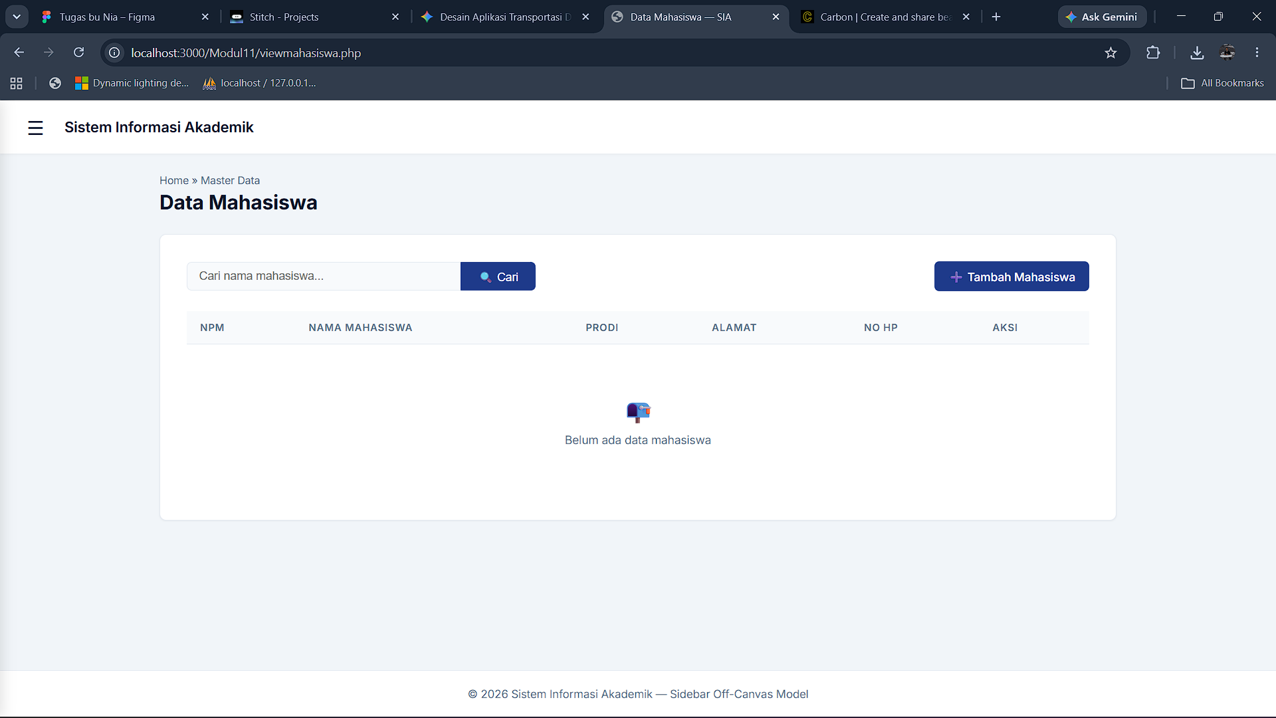

- Tampilan Tambah Mahasiswa
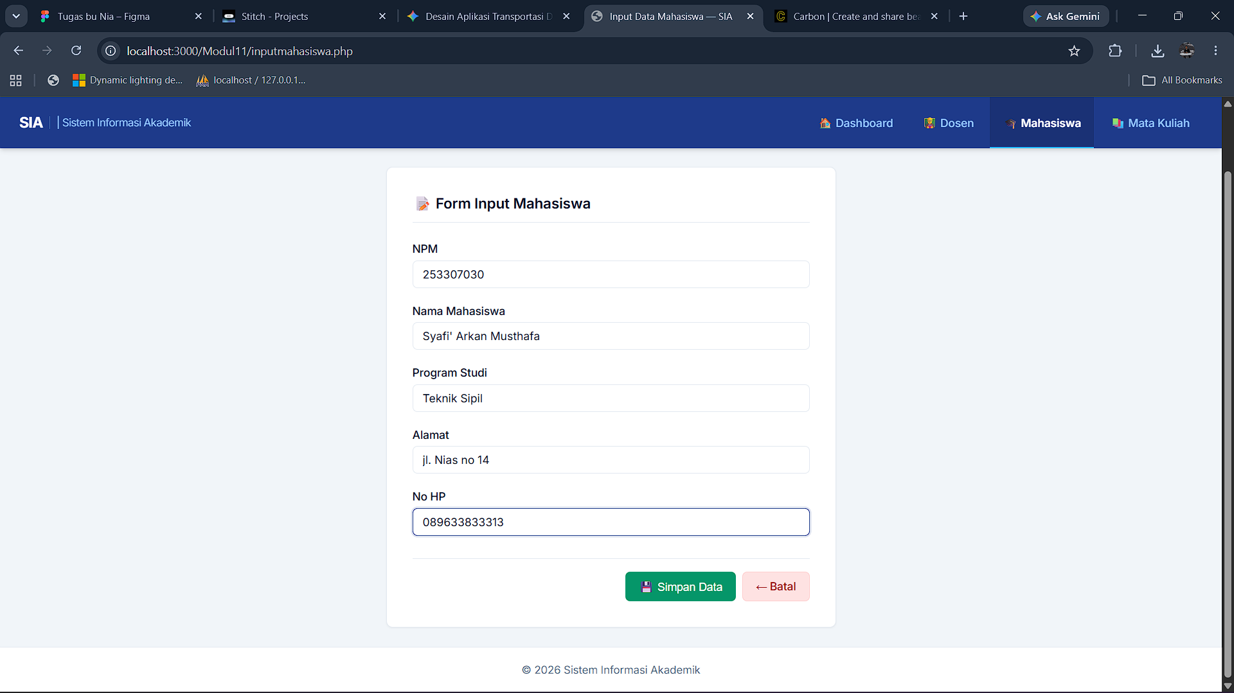

- Tampilan Edit Mahasiswa
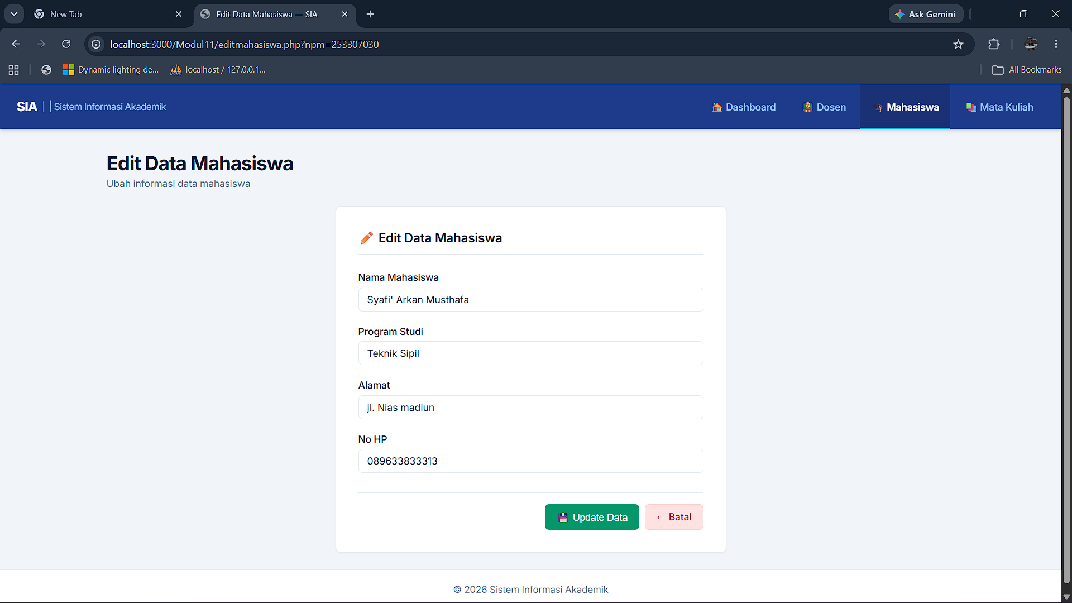

- Tampilan Mata Kuliah
Code :
<?php
include("koneksi.php");

// Fitur pencarian
$search = "";
$whereClause = "";
if (isset($_GET['search']) && !empty($_GET['search'])) {
$search = mysqli_real_escape_string($link, $_GET['search']);
$whereClause = " WHERE namaMK LIKE '%$search%'";
}

$query = "SELECT * FROM t_matakuliah" . $whereClause . " ORDER BY kodeMK ASC";
$result = mysqli_query($link, $query);
?>
<!DOCTYPE html>
<html lang="id">
<head>
<meta charset="UTF-8">
<meta name="viewport" content="width=device-width, initial-scale=1.0">
<title>Data Mata Kuliah — SIA</title>
<link rel="stylesheet" href="style.css">
</head>
<body>
<div class="app-wrapper">

<div class="sidebar-overlay" id="sidebarOverlay"></div>

<aside class="sidebar" id="sidebar">
<div class="brand">
<div>SIA <span>Academic</span></div>
<button class="close-btn" id="closeSidebar">&times;</button>
</div>

<div class="sidebar-profile">
<div class="avatar">👤</div>
<div>
<div>Administrator</div>
<div style="font-size:0.75rem; color:#94a3b8; font-weight:400;">admin@sia.edu</div>
</div>
</div>

<ul class="sidebar-menu">
<div class="menu-header">Dashboard</div>
<li class="<?php echo (basename($_SERVER['PHP_SELF']) == 'index.php') ? 'active' : ''; ?>"><a href="index.php">🏠 Dashboard Akademik</a></li>

<div class="menu-header">Master Data</div>
<li class="<?php echo (in_array(basename($_SERVER['PHP_SELF']), ['viewdosen.php', 'inputdosen.php', 'editdosen.php'])) ? 'active' : ''; ?>"><a href="viewdosen.php">👨‍🏫 Data Dosen</a></li>
<li class="<?php echo (in_array(basename($_SERVER['PHP_SELF']), ['viewmahasiswa.php', 'inputmahasiswa.php', 'editmahasiswa.php'])) ? 'active' : ''; ?>"><a href="viewmahasiswa.php">🎓 Data Mahasiswa</a></li>
<li class="<?php echo (in_array(basename($_SERVER['PHP_SELF']), ['viewmatakuliah.php', 'inputmatakuliah.php', 'editmatakuliah.php'])) ? 'active' : ''; ?>"><a href="viewmatakuliah.php">📚 Data Mata Kuliah</a></li>
</ul>
</aside>

<div class="main-body">

<header class="top-header">
<button class="toggle-btn" id="openSidebar">☰</button>
<div class="header-title">Sistem Informasi Akademik</div>
</header>

<main class="content-area fade-in">
<div class="breadcrumb-container">
<div class="path">Home » Master Data</div>
<h1>Data Mata Kuliah</h1>
</div>

<div class="card">
<div class="actions-bar">
<form class="search-bar" action="viewmatakuliah.php" method="get">
<input type="text" name="search" placeholder="Cari mata kuliah..." value="<?php echo htmlspecialchars($search); ?>">
<button type="submit">🔍 Cari</button>
</form>
<a href="inputmatakuliah.php" class="btn btn-primary">➕ Tambah Mata Kuliah</a>
</div>

<table class="data-table">
<thead>
<tr>
<th>Kode MK</th>
<th>Nama Mata Kuliah</th>
<th>SKS</th>
<th>Jam</th>
<th>Aksi</th>
</tr>
</thead>
<tbody>
<?php
if (mysqli_num_rows($result) > 0) {
while ($data = mysqli_fetch_assoc($result)) {
echo "<tr>";
echo "<td>$data[kodeMK]</td>";
echo "<td>" . htmlspecialchars($data['namaMK']) . "</td>";
echo "<td>" . htmlspecialchars($data['sks']) . "</td>";
echo "<td>" . htmlspecialchars($data['jam']) . "</td>";
echo '<td class="action-links">
<a href="editmatakuliah.php?kodeMK='.$data['kodeMK'].'" class="btn btn-warning btn-sm">✏️ Edit</a>
<a href="hapusmatakuliah.php?kodeMK='.$data['kodeMK'].'" class="btn btn-danger btn-sm"
onclick="return confirm(\'Anda yakin akan menghapus data?\')">🗑️ Hapus</a>
</td>';
echo "</tr>";
}
} else {
echo '<tr><td colspan="5"><div class="empty-state"><div class="icon">📭</div><p>Belum ada data mata kuliah' . ($search ? ' untuk pencarian "' . htmlspecialchars($search) . '"' : '') . '</p></div></td></tr>';
}
?>
</tbody>
</table>
</div>
</main>

<footer class="footer">
&copy; <?php echo date('Y'); ?> Sistem Informasi Akademik — Sidebar Off-Canvas Model
</footer>
</div>
</div>

<script>
const sidebar = document.getElementById('sidebar');
const overlay = document.getElementById('sidebarOverlay');
const openBtn = document.getElementById('openSidebar');
const closeBtn = document.getElementById('closeSidebar');

function toggleSidebar() {
sidebar.classList.toggle('active');
overlay.classList.toggle('active');
}

openBtn.addEventListener('click', toggleSidebar);
closeBtn.addEventListener('click', toggleSidebar);
overlay.addEventListener('click', toggleSidebar);
</script>
</body>
</html>

- Tampilan Running Mata Kuliah
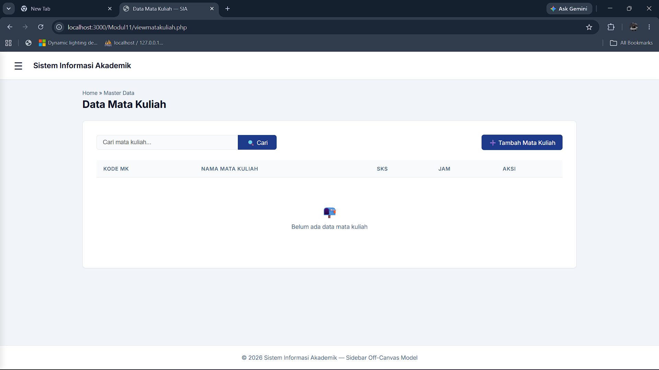

- Tampilan Tambah Mata Kuliah
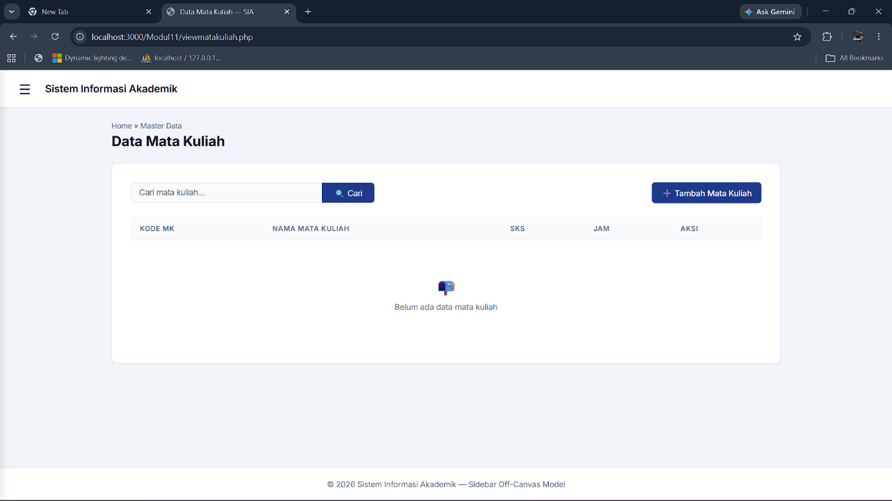

- Tampilan Edit Mata Kuliah
